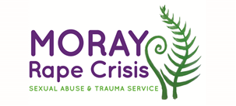
Vacancies: Treasurer
Established in 2018, Moray Rape Crisis provides therapeutic support, information and advocacy for children, young people and adults of all genders, aged 11 and over, in the Moray area, who have experienced any form of sexual violence at any time in their lives, including rape, sexual assault, childhood sexual abuse and sexual exploitation. We also work directly with young people in schools and youth settings, and with strategic partners, towards preventing sexual violence.
We are looking for a Treasurer to join our dedicated Board of Trustees
We are seeking a new Treasurer to help guide and advise the Board of Trustees on financial matters. Working to a feminist ethos, applicants should have finance/accounting experience and knowledge of financial systems and reporting. Training in financial governance will also be provided.

Please note only women need apply under Schedule 9, Part 1 of the Equality Act 2010.

We are committed to a diverse and inclusive organization, and especially welcome applications from women of colour and LGBTI women.

Recruitment packs are available to download from Goodmoves. You can find out more about our work here

The closing date for all applications is Monday 9th May at 5pm.

