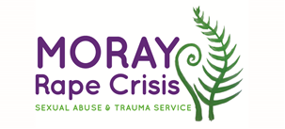
Vacancies: Trustees
Established in 2018, Moray Rape Crisis provides therapeutic support, information and advocacy for children, young people and adults of all genders, aged 11 and over, in the Moray area, who have experienced any form of sexual violence at any time in their lives, including rape, sexual assault, childhood sexual abuse and sexual exploitation. We also work directly with young people in schools and youth settings, and with strategic partners, towards preventing sexual violence.
We are looking for Trustees to join our dedicated Board of Trustees
We are seeking motivated Trustees to help govern our growing and developing service in Moray.
Working to intersectional feminist values, we are seeking a diverse range of women with a commitment to the work we do across Moray. We are particularly interested in applicants from less represented groups, and those with knowledge and experience of governance, strategy, HR and finance.

Please note only women need apply under Schedule 9, Part 1 of the Equality Act 2010.

We are committed to a diverse and inclusive organization, and especially welcome applications from women of colour and LGBTI women.

Recruitment packs are available to download from Goodmoves. You can find out more about our work here

The closing date for all applications is Monday 9th May at 5pm.

